**CDAC Mumbai PG-DAC August 24**

**Assignment No- 4**

1) Write a program that demonstrates widening conversion from int to double and prints the result.

Solution-

public class WideningConversion {

public static void main(String[] args) {

int i= 42;

double d = i;

System.out.println("Integer value: " + i);

System.out.println("Double value after widening conversion: " + d);

}

}

2) Create a program that demonstrates narrowing conversion from double to int and prints the result.

public class NarrowingConversion {

public static void main(String[] args) {

double d= 42.99;

int i= (int) d;

System.out.println("Double value: " + d);

System.out.println("Integer value after narrowing conversion: " + i);

}

}

3) Write a program that performs arithmetic operations involving different data types (int, double, float) and observes how Java handles widening conversions automatically.

public class ArithmeticOperations {

public static void main(String[] args) {

int intValue = 10;

double doubleValue = 2.5;

float floatValue = 5.3f;

data types

double result1 = intValue + doubleValue; // int + double = double

float result2 = intValue + floatValue; // int + float = float

double result3 = doubleValue * floatValue; // double * float = double

System.out.println("Result of int + double: " + result1);

System.out.println("Result of int + float: " + result2);

System.out.println("Result of double * float: " + result3);

}

}

4) Write a Program that demonstrates widening conversion from int to (double,float, boolean, string) and prints the result.

public class WideningConversionDemo {

public static void main(String[] args) {

int intValue = 42;

double doubleValue = intValue;

System.out.println("Widening conversion from int to double: " + doubleValue);

float floatValue = intValue;

System.out.println("Widening conversion from int to float: " + floatValue);

boolean booleanValue = (intValue != 0);

System.out.println("Conversion from int to boolean: " + booleanValue);

String stringValue = Integer.toString(intValue);

System.out.println("Conversion from int to String: " + stringValue);

}

}

**Interview Questions**

**Note: Write down this interview question on your notebook ,Take a screenshort & Paste that SS in the word document & upload on your Github.**

**What does the static keyword mean in Java? Explain the difference between static and non-static methods.**

1. What is the role of the static keyword in the context of memory management.

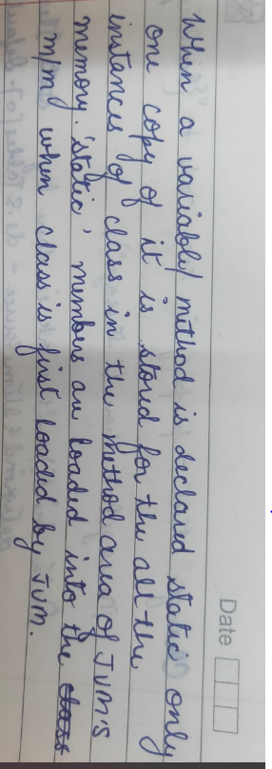

1. Can static methods be overloaded and overridden in Java?Howstatic variables shared across multiple instances of a class?

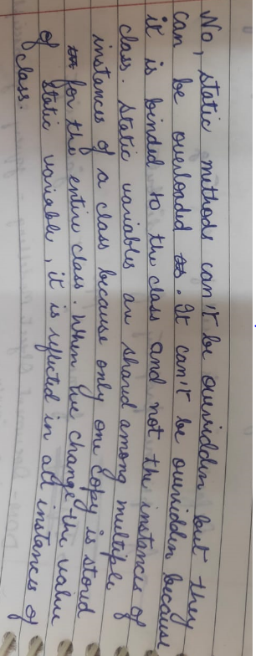

1. What is the significance of the final keyword in Java?

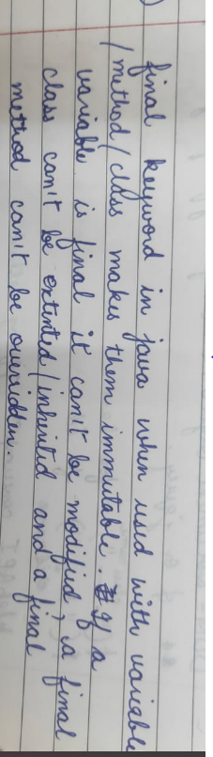

1. What are narrowing and widening conversions in Java?

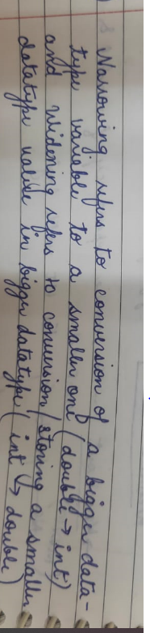

1. Provide examples of narrowing and widening conversions between primitive data types.

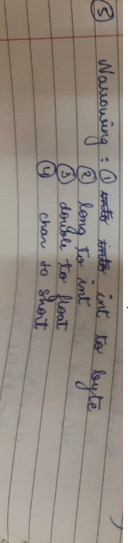 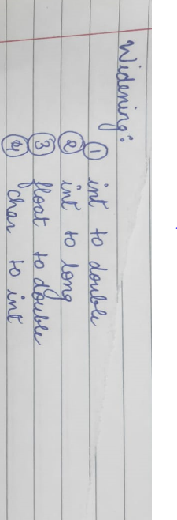

1. How does Java handle potential loss of precision during narrowing conversions?

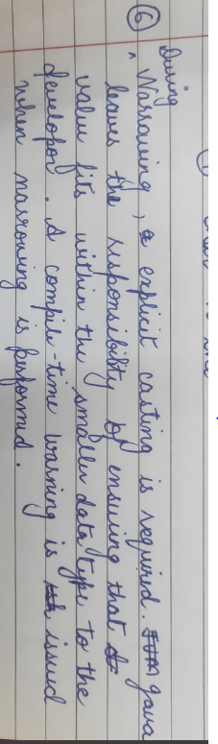

1. Explain the concept of automatic widening conversion in Java.

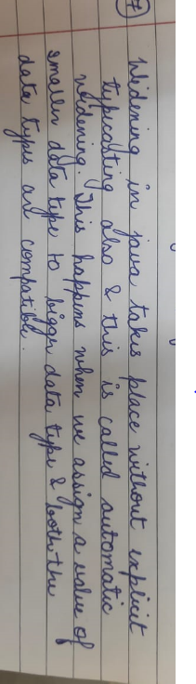

1. What are the implications of narrowing and widening conversions on type compatibility and data loss?

